Evaluator: Pontus Svensson

Reviewer: Leonardo Iwaya

DATE: 26/03/2024

Task: Assess the risk for stroke

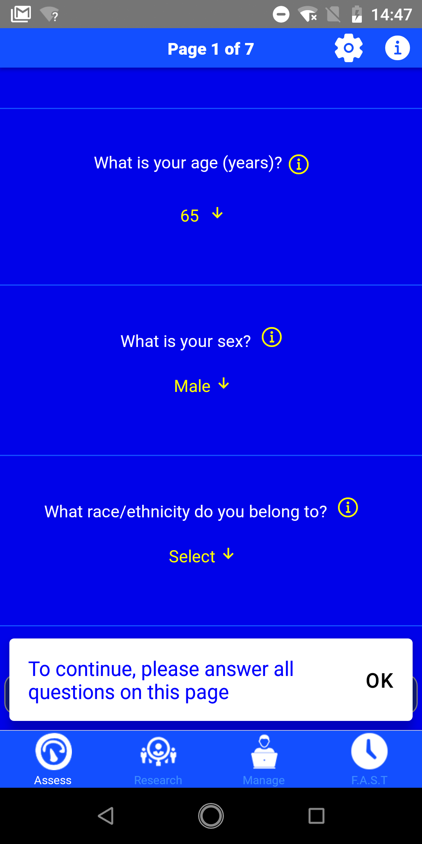

1. In the screenshot to the right, the user is prompted to answer specific questions to evaluate their stroke risk. If a question has been left unanswered, an error message in plain blue text appears. While the prompt does clarify what action the user should take, this approach contradicts the ninth heuristic, **"Help Users Recognize, Diagnose, and Recover from Errors"**, which recommends using traditional error messages displayed in bold and red text.
2. Considering the demographic of older and elderly users for this application, it is advisable toimplement larger font sizes for most text elements. Given that this group may have poorer eyesight compared to the average user, increasing the font size would enhance readability. As of now, the first heuristic is violated, **visibility of system status**.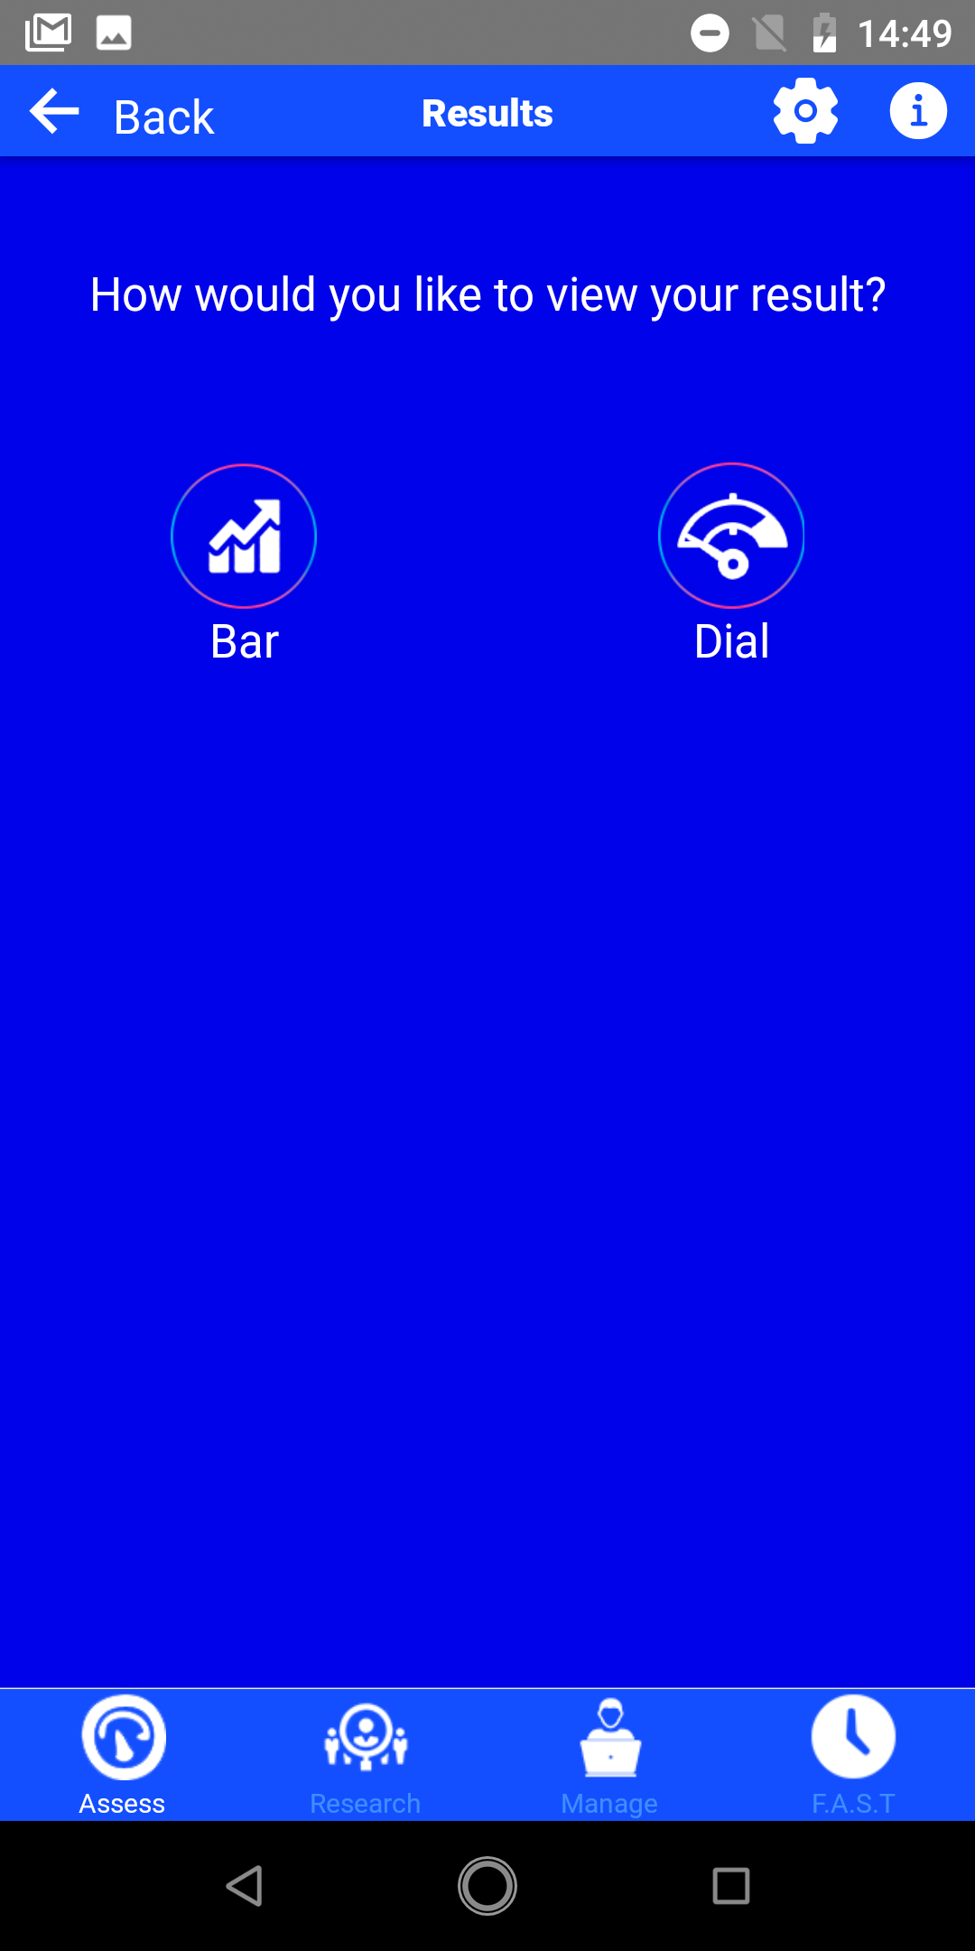
3. Upon completing the assessment, the user is given the choice to view their assessed stroke risk either on a bar or on a dial, as seen in the screenshot to the right. Both views are displayed below. However, the choice between these two options seems unnecessary since they offer the same information. Opting for just one of these options would align better with the eighth heuristic, **aesthetic and minimalist design**, which emphasizes focusing on essential content and removing unnecessary distractions.

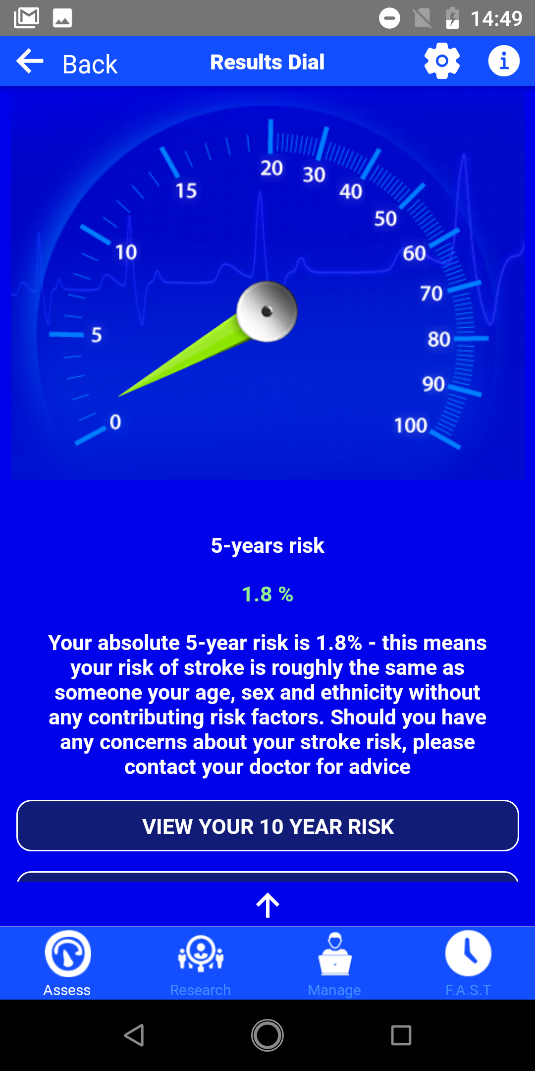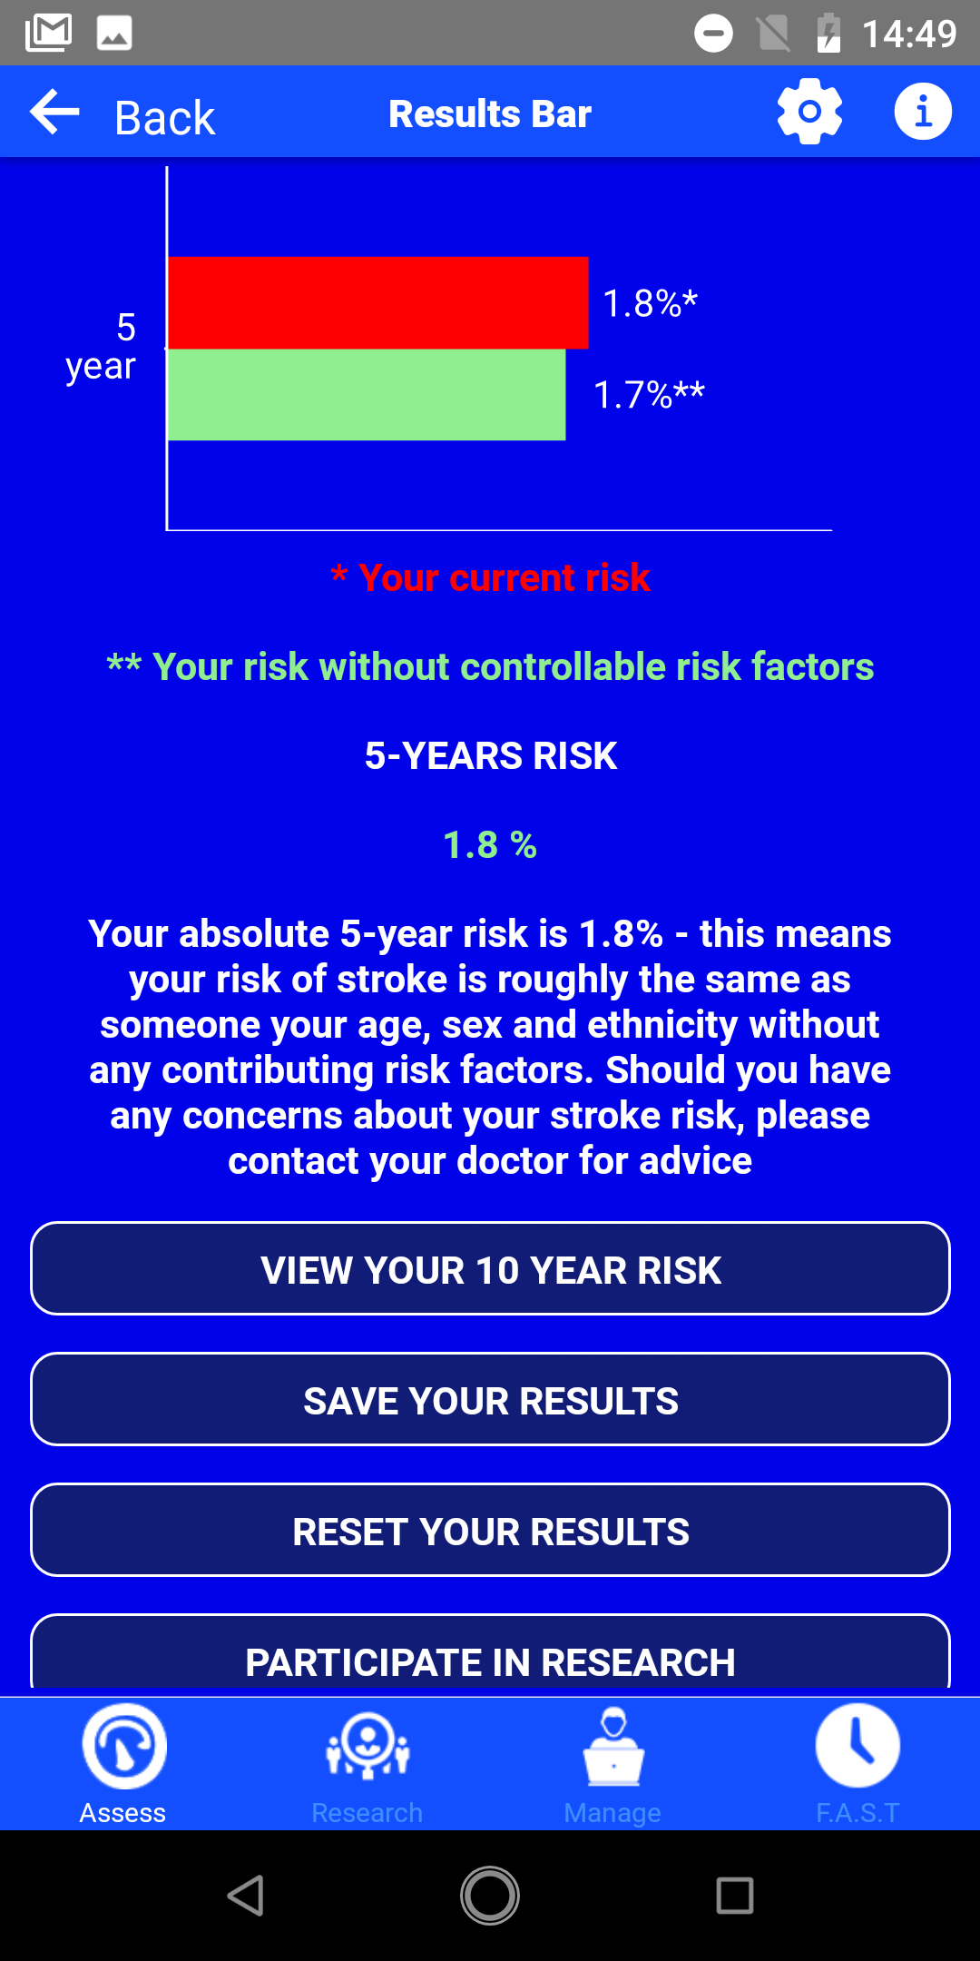

1. In the screenshot displayed on the right, the user has accessed the window labelled "F.A.S.T.," representing Face, Arm, Speech, and Time. This acronym may not be familiar to most lay users, potentially complicating the design. Adding an explanation about the F.A.S.T acronym (and where it comes from) and/or utilizing a more readily understandable phrase would align with heuristic number two, **"match between system and the real world,"** which advocates for using language and terminology that users are familiar with. Given that some users may not be acquainted with the term, adopting a more universally recognized phrase would enhance usability. Furthermore, instead of removing or changing the name, an explanation about the F.A.S.T acronym within a “know more” screen or tooltip would align with heuristic number ten, **“help and Documentation”**.